Year 8 Spreadsheet Quiz Challenge
In your ICT lessons you have learnt how to create quizzes using spreadsheets. You are going to use the skills you learned to put together a series of maths quizzes which will be used to test students across KS3.
You will work in groups/pairs and create a quiz together on the computers. You will choose a topic from one of the groups below to make your quiz on. Your teacher will tell you which group of topics to choose from.
Only one group/pair of students per class can make a quiz on each topic. You need to check with your teacher that the topic you have chosen is okay before starting to make your quiz.
Group A | Group B | Group C | Group D
Properties of 3D shapes | Finding missing angles in triangles | Solving 2-step equations | Writing numbers in standard form
Nets of shapes | Solving one-step equations | Finding the area and circumference of circles | Expanding and simplifying double brackets
Converting between millimetres and centimetres | Finding the area of triangles | Naming graphs (y=mx+c) | Using reverse percentages to solve problems
Finding the area and perimeter of rectangles | Multiplying and dividing numbers by powers of 10 | Finding the n^{th} term | Finding interior angles in polygons
Rounding numbers to multiples of 10 | Rounding to 1 or 2 decimal places | Using exchange rates to convert currencies | Using Pythagoras to find missing sides in triangles
Matching equivalent fractions, decimals and percentages. | Finding percentages of amounts | Expanding single brackets | Solving problems with indices
Continuing sequences | Substituting into simple expressions | Changing the subject of a formula | Finding missing information in similar shapes
Finding the number of lines of symmetry in a shape or pattern | Using the speed equation to solve problems | Dividing quantities using ratios | Factorising expressions
Finding the rotational symmetry of a shape or pattern | Collecting like terms | Rounding to a number of significant figures | Writing recurring decimals as fractions
Each quiz should have at least 10 questions. You will need to work out the answers for each question so that you can program them into your quiz.
You can find examples of questions on the internet or in your textbooks. If you need an image for your question, you can either create the image yourself or copy and paste one off the internet.
Double click the link below to get a template of a quiz about famous people.
[If you have a paper copy of this your teacher will let you know where to find the spreadsheet file]
N.B. When doing the Spreadsheet Quiz task, if the answer to a question is a number the number should NOT be enclosed in inverted commas in the formula.
=IF(B12=2019,"Correct","Incorrect") as opposed to =IF(B12="2019","Correct","Incorrect")
If the answer is a word it should be enclosed in inverted commas.
Remember:
- Clicking on a cell in the Spreadsheet shows you the information that is in that cell. You should be able to simply edit this information rather than programming the Spreadsheet from scratch
- Stick to questions which only have one correct answer
- If the answer is a word, check your spellings
- Your quiz should have at least 10 questions
- You will probably need to edit the total that your quiz is out of
- Save your work – your teacher may also ask you to save it in a certain area
- Protect your work to stop others changing the programming – see the information below
Once you have finished your quiz you will need to protect your work so that when students are doing your quiz they can’t alter the programming. To do this:
- Click on the “File” tab at the top of the screen
- Click on the “Protect Workbook” icon under “Info” on the side bar.
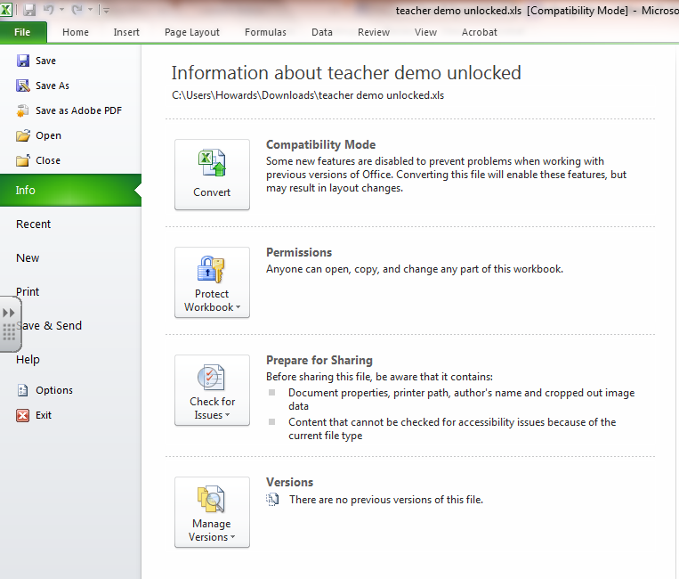
- Select “Protect current sheet” in the drop down menu and, without making changes, click OK.
